*I phone mobile*

I phone X s

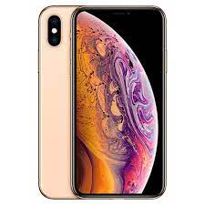

Apple iPhone XS smartphone. Announced Sep 2018. Features **5.8″ display**, Apple A12 Bionic chipset, Dual: 12 MP (f/1.8, 26mm, 1/2.55″, 1.4µm) + 12 MP primary

**PRICE / 74,000 PRK**